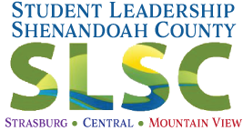

2022

Student Leadership Shenandoah County (SLSC)

Sponsor Opportunities

June 6 – 10, 2022
Student Leadership Shenandoah County (SLSC) is a one-week interactive, informative program designed to strengthen and prepare high school sophomores and juniors for personal, organizational, and community leadership. A half-day opening retreat and leadership journey overview launches the program, followed by 4 daily sessions. A graduation celebration is held.
SLSC offers emerging young leaders opportunities for skill building and leadership development. The program includes a comprehensive examination of Shenandoah County, and encourages participants to apply their leadership skills through community and school projects.

Student Sponsor: $500
- Sponsor a student in the SLSC program
- Company logo on SLSC webpage & program

Sponsorship Confirmation by March 11, 2022 to director@shenandoahcountychamber.com

