Shenandoah County Chamber of Commerce
Community Leadership Program
Purpose:
To develop and foster leadership potential in the community to ensure citizen involvement, community prosperity, and overall community success in Shenandoah County.
Objectives:
To develop the skills of participants so they will be able to provide the leadership necessary to address community needs.
To enhance an understanding of the complex issues facing Shenandoah County through educational programs, exposure to community leaders and the structures they operate within, and through discussions on current issues facing the County.
Format:
This is an eight-month program from April through November. Sessions will be held once a month during this timeframe on a Friday and will generally run 8:00-4:30. Lunch and a light breakfast are provided for each session. Topics include Leadership, Agriculture/Tourism, Local Government, Education, Public Safety, Health Care, Business/Industry, Non-Profit, and the final session involves group presentations from the cohort. Sessions are led by a combination of community leaders, professional facilitators, and specialists in the respective fields.
Tuition:
Tuition must be paid up front by either the participant or employer (participants or their employer’s must be a current Chamber member). Limited scholarships may be available and are awarded based on need. The tuition for the 2022 program is $250.
Application:
An application form must be completed by all participants. The maximum number of participants will be determined by the Chamber each year.
Board of Directors:
Consists of selected business leaders invited by the Chairperson to select the Leadership Shenandoah County participants. Each Director will coordinate and facilitate their respective Session.
The Board consists of the Chamber Board Representative, County Administrator, SCPS Superintendent, Chamber President/CEO and representatives from Industry/Business, Non-Profit , and the Healthcare sectors.

2022 COURSE OUTLINE
Days typically begin at 8:00 a.m. and end at 4:30 p.m.
Attendance is mandatory

April 8, 2022, 8:30 a.m. – 4 p.m. Location: TBD
Orientation Session and Retreat

April 22, 2022
Local Government – An overview of the structure and function of our local government along with discussion of government’s role in addressing local challenges. This class requires independent attendance at a county government meeting prior to the session.

May 20, 2022
Health Care and Human Needs–An overview of medical care in Shenandoah County including tours of SMH, Dept. of Social Services, clinics, and special care facilities. Discussions will focus on the current health care and human needs issues facing our community.
June 10, 2022
Agriculture & Tourism-Discover agricultural resources as they affect Shenandoah County. Accomplished by involvement in touring various farms, facilities and venues relating to agricultural and tourism activities.

July 8, 2022
Non-Profit – We discover Shenandoah County’s non-profits and learn the role these entities serve in commerce and our quality of life

August 12, 2022
Public Safety – A look at our fire service and law enforcement agencies and how they interact. Includes tours of the RSW Regional Jail, Sheriff’s Department, and County Courthouse.

September 9, 2022
Business/Industry – A look at the diversity of the local business economy including a statistical overview of the county in the Northern end of the County. Includes tours of several area businesses and industries.

October 14, 2022
Business/Industry – A look at the diversity of the local business economy including a statistical overview of the county in the Southern end of the County. Includes tours of several area businesses and industries.

November 11, 2022
Education –A look at the structure and operation of our public and private educational systems. Includes discussion and interaction relating to education’s role in our economic prosperity. This class requires independent attendance at a Shenandoah County School Board meeting prior to the session.

Wednesday, Dec 7, 2022, 5:30 pm – 6:30 pm Location: TBD
Graduation – A special event honoring those who have completed the Leadership Shenandoah County Program, sponsored by the Northern Virginia Daily

You are invited to apply for the 2022 Leadership Shenandoah County program…
A comprehensive series of lectures, discussions, and field trips designed to educate and develop community and business leaders about the present and future needs of Shenandoah County.
This program is made possible by these wonderful Chamber Annual Sponsors

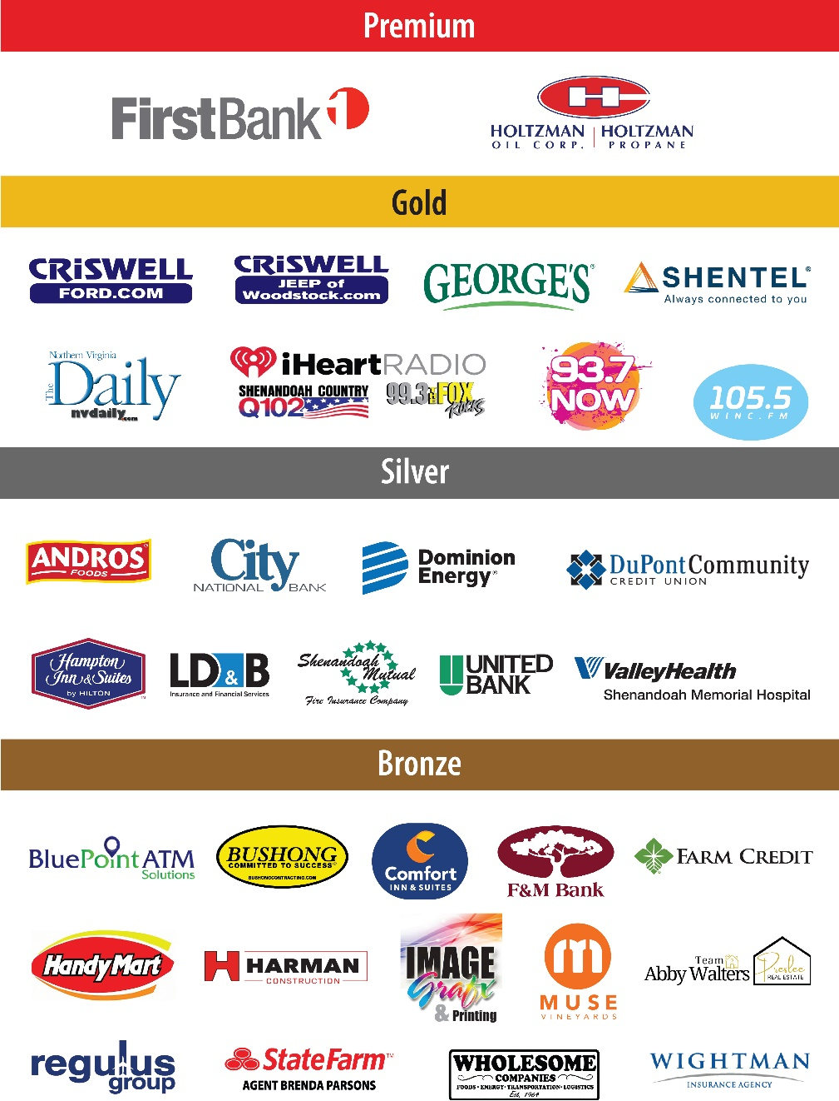

PURPOSE
The Leadership Shenandoah County program is designed to expose current and future leaders to all aspects of Shenandoah County. The program’s purpose is:
- To identify community leaders of diverse backgrounds
- To develop their potential and desire to accept civic responsibilities and leadership roles
- To expose community leaders to the problems and opportunities that face Shenandoah County
- To build a realistic understanding of leadership in today’s complex society
- To open a dialogue among emerging and current community leaders
- To acquaint leaders with the processes, programs, opportunities and challenges for individual involvement in Shenandoah County
SELECTION CRITERIA
The most important factor in participant selection is identifying those individuals who are most apt to use their leadership knowledge and skills for the long-term benefit of the community.
Based upon this criteria, individuals selected will:
- Have demonstrated commitment through past and current community activities
- Have attained a leadership position within their business or organization or have the potential for advancement to senior leadership positions.
- Have a sincere commitment, motivation and interest in serving their community
- Be interested in, or intend to seek, leadership roles in the community
- Represent a cross section of the business community of all ages and geographic representation, including government representatives, professional leaders, and community service volunteers.
The selection committee is comprised of the Leadership Shenandoah County Advisory Board

GRADUATION & ATTENDANCE REQUIREMENTS
So that participants can gain full benefit from the Leadership Shenandoah County program, course completion is based upon meeting attendance requirements for class sessions. The equivalent of more than two days of absences prohibits graduation at the end of the session year. Attendance will be checked in the morning, after lunch, and at the end of the day. If a day includes a bus tour, class members are required to ride the bus during the entire session. The bus tour attendance is required except in cases where there is the need for a documented accommodation. If attendance on any session day is not possible the County Chamber President must be notified.

TUITION
Tuition covers the cost of all session materials, field trips, refreshments, meals, transportation and the graduation ceremony. Limited scholarships may be available for qualified scholarship applicants.

Confidential Application
2022
No hand-written applications will be accepted
Please be sure to follow delivery instructions
Application Due: March 1, 2022

Name
First Middle Last Preferred Name

Mailing Address
Street City State Zip

Home or Cell Phone Business Phone

Email

Date of Birth Length of Residence in Shenandoah County

Company/Sponsoring Organization
Organization Mailing Address
Nature of Business
Your Title

- EDUCATION
A. Name of School Dates of Attendance Degree Major
(begin with high school, then college(s), or trade schools and/or specialized training)

- EMPLOYMENT
(List in chronological order, accounting for all time periods, including military, starting with the most current)
Employer Title/Responsibility Dates of Employment Reason for Leaving

- ACTIVITY DATA
Have you ever participated in another Community Leadership program? Yes No

If yes, which program?

Current Major Volunteer Role

Organization

Position Hours per month

Describe responsibilities:

On average, how much time each month do you commit to volunteer work outside of your profession?

Please list your current business/professional affiliations Hours per month

Please list your current community and/or social affiliations Hours per month

If you have not previously had the time or interest to become involved in civic and community affairs, what conditions have changed to allow you to become involved? On which community boards, committees, or groups would you like to become active?

- LETTERS OF RECOMMENDATION
Please include one letter of recommendation (no more than 500 words)

- GENERAL INFORMATION
The primary goals of Leadership Shenandoah County are to develop and train leaders and to improve the quality of decision-makers for the future who can provide the community with greater continuity in community leadership.

- Why do you want to participate in Leadership Shenandoah and what do you hope to gain from your participation?

- Identify what you believe to be the three (3) most pressing problems facing Shenandoah County today. Explain why, and make recommendations for addressing and resolving these problems and issues.

Use separate sheet(s) for your response to 4B. Not to exceed 500 words per problem or issue.

- TUITION
The tuition for Leadership Shenandoah County is $250 per participant. Payment is due upon acceptance into the program – do not enclose payment with this application. Limited scholarships may be available and payment plans are possible. If you would like to be considered for a scholarship please submit an explanation of need (250 words). No refunds of tuition or transfers of class selection permitted. Applicants will be notified of selection status the week of March 7, 2022.

- COMMITMENT
If a business or organization is sponsoring your participation in Leadership Shenandoah County, the sponsor or employer must sign this form to indicate their support of your participation in the program. Applications will not be considered without this signature.

Sponsor or Employer Signature

Print Name Title

Applicant Signature Date

- DELIVERY INSTRUCTIONS AND DEADLINE
Please do not send payment with application
Completed applications must be delivered by email, hand or postal mail (no faxes) to:
Shenandoah County Chamber of Commerce
PO Box 605, Woodstock, VA 22664

Office: 103 S Main Street, Woodstock, VA 22664

No hand-written applications will be accepted.

QUESTIONS?
Please call Sharon Baroncelli at 540-459-2542
APPLICATION DEADLINE: No later than 3:00 p.m. on Tuesday, March 1, 2022

